From: <https://strategic-culture.org/news/2022/05/18/us-nato-waging-war-with-russia-in-ukraine-but-russia-assured-victory-russell-bentley/>

The U.S. and NATO Are Waging War With Russia in Ukraine… But Russia Is Assured of Victory – Russell Bentley

Interview by Finian Cunningham of Russell Bentley

May 18, 2022

**Russell Bentley has been living in the Donetsk People’s Republic for eight years where he now has obtained official citizenship.**

Western news media are spinning wild delusions about Russia facing failure and defeat in Ukraine, says Russell Bentley, a former American soldier who has been fighting and living in the Donbass for the past eight years. In the following interview for Strategic Culture Foundation, he says Russia is assured of a stunning victory to defeat not just the Kiev regime but also its handlers in the U.S. and NATO powers.

This week, the New York Times and BBC, for example, belatedly and begrudgingly admitted that Russia had “triumphed” in Mariupol, the southern port city where for weeks the same Western media have been lionizing the “brave defenders” belonging to the NATO-sponsored and openly Nazi-affiliated Azov Battalion.

Russell Bentley has gained an international following for his courage and truth-telling. In this interview, he also bears testimony to the ravages and war crimes committed by what he calls the Nazi Kiev regime against the civilian population. He says it was vital that Russia launched its special military operation (Operation Z) on February 24 because the Kiev regime and the United States in concert with other NATO powers were planning a major deadly offensive against the Donbass. That offensive was pre-empted by Russia’s intervention. He says that while Russia has the military upper hand, the NATO powers are up to their necks in this conflict in a way that threatens a full-on world war. And the Western media are misleading the public about the grave dangers, cynically spouting lies about “defending Ukraine” instead of the reality that the U.S., NATO and the European Union are supporting Nazis and war criminals. He traces a historical political line back to the Second World War and how the Western powers assimilated German Nazi remnants into their power structures with baleful consequences that are manifest today.

Originally from Texas, Russell Bentley has been living in the Donetsk People’s Republic for eight years where he now has obtained official citizenship. He left the United States in late 2014 to join the DPR army to defend the breakaway republic from the NATO-backed Kiev regime. He said the suffering of innocent people at the hands of “NATO Nazis” compelled him to volunteer. Bentley has fought on the frontlines where he has seen many of his comrades-in-arms killed. He recently attended the funeral of one of them, Sergey Lysenko, a fighter and poet who was killed in the battle for Volnavaha on May 9, Victory Day. More recently, he has been [broadcasting](https://mobile.ok.ru/video/10159326605) and working in communications to convey to the world what is really happening in the Donbass and Ukraine. He wryly points out that his broadcasting videos have been censored by Youtube while the U.S.-owned media platform continues to permit Ukrainian Nazi battalions to pump out their propaganda.

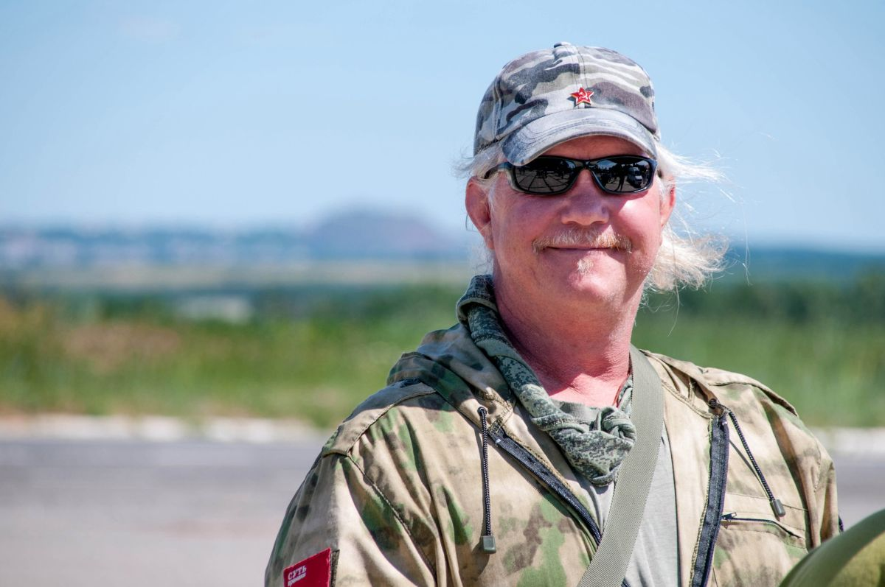

**Interview**

**Question:** Western news media have been full of reports on how Russia’s military intervention in Ukraine is a failure. From the perspective of people on the ground in Donbass, how is Russia’s campaign going?

**Russell Bentley:**A lot of people in Donbass and Russia are concerned about the pace and even the conduct of Operation Z, especially in its early stages. In the beginning, some serious mistakes were made, but this is inevitable in every war. Russia has genuinely made every effort to minimize civilian casualties and destruction of infrastructure, what U.S. Nazis call “collateral damage” when their military invades and destroys countries. The U.S. regime has had total control of all political and military policies and decisions in Ukraine since 2014, and that includes the Ukrop [Ukrainian military] Nazis’ decision to use civilian human shields and to maximize death and destruction. Russia has faced an absolutely ruthless, even diabolical enemy while trying to maintain honor and morality by upholding and conforming to the laws of war, and setting a humane example. It is like a boxer using Marquis de Queensbury rules trying to fight an MMA fighter who also has brass knuckles and a knife. But the boxer is winning – militarily, economically, and politically.

Russia is winning, and we will win. Neither the Ukrainian military nor all of NATO can or will stop Russia from the complete accomplishment of all of the goals set for Operation Z. Nazified Ukraine, under the control of U.S., EU and NATO Nazis, is an existential threat to Russia, and Russia will deal with it as such. Ukraine will be de-nazified and de-militarized as far as Russia deems necessary. Of that, you can be certain.

The fact is that Russia has actually achieved a stunning victory. Standard military doctrine dictates an assault force requires a 3-to-1 numerical superiority to have a reasonable chance of victory, and Russia has achieved all its strategic goals thus far with an assault force of less than 1-to-1. The casualty reports from both sides should be taken with a grain of salt, but no serious observer can deny that Russia has dealt strategic losses to Ukrop army men and equipment while maintaining their own numbers at militarily acceptable and operational levels. Russia has used a small fraction (about 15 percent) of its military capabilities so far in Ukraine. The armchair Generals and keyboard commandos who criticize Russia’s military operations in Ukraine are for the most part far too ignorant of military tactics and strategy to even be considered qualified to have an opinion on the subject, so they should be silent. Don’t worry, we got this.

**Question:** There have been muted admissions in Western media that the United States is supplying intelligence to help the Kiev regime forces to target Russian troops. Have you seen much evidence of the U.S. and NATO providing intelligence to enable Kiev military operations?

**Russell Bentley:**Yes. The U.S., along with their EU and NATO henchmen, have had complete political, economic and military control over Ukraine since 2014. Every dead civilian and soldier, every person crippled for life, every blown-up or burned-down house, every psychologically traumatized child, every hungry, homeless dog and cat, on both sides, are absolutely and primarily the criminal responsibility of the genuine Nazis who own and control the U.S., EU, and Ukrainian regimes, and their militaries. The entire Ukraine war, ongoing since 2014 is in reality a proxy war of Western fascism against Russia, because Russia is the main obstacle to their objective of world domination.

The U.S. and NATO have had their Special Forces and highly trained mercenaries (including ISIS terrorists) in Ukraine since 2014. I can confirm this personally. The provision of intelligence to Ukraine from satellite, AWACS, drones, ELINT and SIGINT is a major force multiplier, as is the provision of expert advisors and instructors who also have been directly involved in frontline combat operations since 2014, which I can also personally confirm. The provision of multi-billions of dollars worth of weapons and ammo, along with Western orders to “fight Russia to the last Ukrainian”, lays bare the Western Nazis’ intent to leave Ukraine an irrecoverably failed state, just as they have done in

* Afghanistan,
* Iraq,
* Libya,
* Somalia and
* Yemen

among other countries. **Ukraine is currently under genuine foreign Nazi occupation**, absolutely no less than it was from 1941 to 1943. The Ukrainian army today does not “defend” Ukraine, it deliberately destroys it, on behalf of a foreign and genuinely fascist regime that controls Ukraine from Kiev, but is actually based in Washington, London and Brussels. And Tel Aviv.

Without U.S. and NATO’s continuing support, Ukraine’s quisling regime would have already surrendered, the war would have ended, and thousands of lives would have been spared. So the absolute moral, legal and practical responsibility for the start, escalation, and continuation of this war lies with them. **Russia doesn’t start wars, we finish them.** And we will finish this one as well, victoriously, one way or another. It is up to our enemies in the U.S. and NATO to decide how much destruction and suffering they will cause Ukraine before their inevitable political de-nazification and military defeat.

**Question:** In areas of the Donbass that were formerly under the control of the Kiev regime forces but are now under the control of Russian forces, what has been the reaction of citizens to the changing circumstances?

**Russell Bentley:**I have made multiple trips to newly liberated areas, particularly Volnavaha and Mariupol, where some of the heaviest fighting and destruction occurred. Of course, no one is happy to see their home or large parts of their city destroyed, but the vast majority, I’d say more than 90 percent, of the people there, are happy to be liberated from the oppression and occupation of Nazi terrorists. The reports of rape, robbery, murder, torture, and human and organ trafficking are legion, but these crimes have now ceased, and are now being counted and investigated, and the perpetrators will be brought to justice.

Russia is bringing in hundreds of tonnes of humanitarian aid per day, every day, and the electric, gas, and water infrastructure is already being repaired or replaced in many of the liberated cities. Meanwhile, the West sends Ukraine billions of dollars worth of lethal military aid, but not a single dollar has been sent to people in the areas that the Kiev regime still claims there are Ukrainian citizens that they are “defending”. The people of Mariupol in particular saw for themselves how Azov Battalion Nazis used civilians as human shields and even slaughtered them in order to try to blame on Russia’s alleged “aggression”. Russia has liberated them from unaccountable Nazi rapists, torturers and murderers. Russia is the only one bringing in humanitarian aid and assisting with reconstruction and repair. Of course, all sane and decent citizens in the liberated zones are very glad to see them. Only the Nazis and war criminals are not.

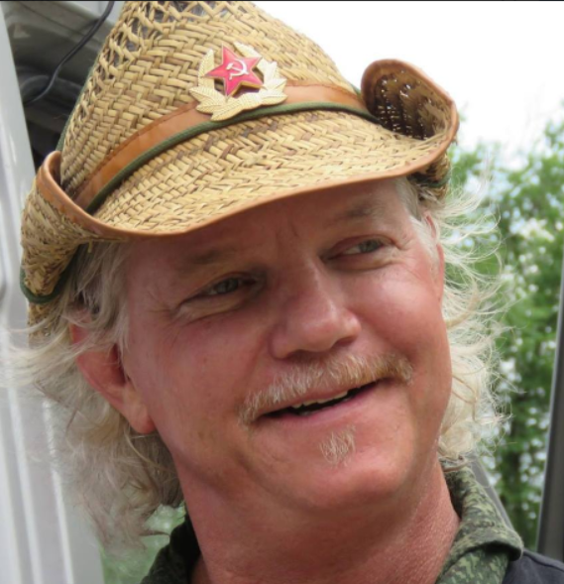

**Question:** During the eight years after the CIA-backed 2014 coup in Kiev, what was life like for the people in the separatist republics of Donetsk and Lugansk (DPR and LPR)?

**Russell Bentley:**Life in a war zone is never easy. Since the people of the Donbass republics stood up and refused to submit to foreign fascist rule in the spring of 2014, they have been under constant military attack, economic blockade and political persecution. And yet we have prevailed, not only survived but thrived, in spite of very difficult conditions. By literally every metric of human life quality, from the cost of living to political freedom, the Donbass republics have fared far better than people in the parts of Ukraine under the Kiev regime.

In Ukraine, the quality of life began a steep decline immediately after the Maidan coup d’état in early 2014. After the new regime was filled with stooges hand-picked by the U.S. State Department and CIA, the Ukrainian military and Nazi terrorist battalions were unleashed against any and all Ukrainian citizens who protested against the coup. This led to massacres in Odessa, Mariupol, Kharkov, Lugansk and Donetsk (among many other places) along with terrorist oppression against any political dissent. Foreign [Gauleiters](https://en.wikipedia.org/wiki/Gauleiter) were brought in and installed, such as

* Ulana Suprin, an American-born physician from a pro-Bandera family who was appointed Minister of Health, and then proceeded to gut the Ukrainian national healthcare system. U.S.-born “investment banker” and
* State Department employee Natalie Jaresco was appointed Minister of Finance of Ukraine and from 2014 to 2016, looted the Ukrainian treasury with impunity.
* The fugitive ex-President of Georgia, Mikhail Saakashvili, (who is now in prison for corruption in Georgia) was appointed Governor of Odessa Oblast (state) from May 2015 to November 2017. Under his reign, Odessa became a major hub for sex slavery and human-organ trafficking, as well as the illegal and unregulated import of toxic waste.

As elsewhere, since the Covid-19 pandemic economic disruptions, prices in the Donbass republics have risen significantly, and even more so in recent months. Wages have to some degree kept pace with prices, and some prices such as rent, utilities and fuel have actually remained static. In spite of an economic blockade by the Kiev regime and the West, the Donbass republics continue to enjoy a very normal and generally satisfactory standard of living. Medical care and education remain free in the republics, and both are of comparable quality to Russia. Wages are higher in Russia, but so are prices, so the standard of living in the republics is generally better than in Ukraine and on par with Russia’s. Russia has a strong military, economic, energy, and food security, so the republics can expect the same in the future. Practically and politically (if not officially) we are part of Russia, and expect and continue to have similar living standards.

**Question:** Has the security situation improved for the populace of the DPR and LPR since Russia launched its military intervention on February 24?

**Russell Bentley:**The most important thing to understand about the Russian intervention into Ukraine is that it was a preemptive defensive move that prevented an imminent and massive military attack by the Ukrainian army on the main cities of the republics – Donetsk, Makeevka, Yasynuvata, Gorlovka and Lugansk. All of these cities are literally on the frontlines, with the city centers a scant 10 or 12 kilometers from Ukrop military positions. Had the Russians hesitated, and the attack occurred as planned, and had the Ukrops made it into our city centers, or even into the heavily populated urban areas on the outskirts, their human-shield strategy would have been immediately implemented, and they would have used our civilian population as shields against Russia’s main military advantages, namely, Russian artillery, missile and air power.

It was (and is) also clear that the second wave of the assault forces, made up of the most ruthless Nazi war criminal battalions, were tasked with genocide and ethnic cleansing of the cities, which would have resulted in hundreds of thousands of civilian deaths, through not only the ensuing urban combat but from intentional and **targeted mass murder of ethnic Russians by Ukrainian “Einsatzgruppen”, exactly as the German Nazis had done in these same cities 80 years before.** And it is an undeniable fact and proven beyond any doubt, that the strategy of human shields, genocide and ethnic cleansing was designed and ordered by U.S. and NATO war criminals. So the Russian intervention saved the populations of our cities that otherwise **would have been doomed had Russia hesitated**.

Since the beginning of **Operation Z** in late February, the Ukrainian shelling that has been ongoing since 2014 has significantly increased, especially targeted attacks on civilians, such as open-air markets and residential areas where our military do not operate. There has been an increase in both shelling and civilian deaths, but compared with the mass slaughter that was planned, there can be no doubt that the Russians saved our people in the tens or hundreds of thousands. Which is certainly an increase in our security.

**Question:** Do you think Russia should have intervened sooner than 2022 to prevent aggression from the NATO-backed Kiev regime?

**Russell Bentley:**Many people do, and for a while, I did too. I now see things differently and much more clearly. Vladimir Putin is the president of Russia, and as he has clearly stated, his job is to protect Russia and the Russian people. Everything else comes second. In 2014, Russia was not prepared militarily, economically, or politically for an incursion into Ukraine, because it must be understood that any incursion into Ukraine risked, and in fact, continues to risk, a full-on confrontation with NATO, which would have been, and still is, not only military but economic, political and informational. Had he overtly intervened in the earlier years, he would have fallen into the trap set for him (and Russia) by the Western Nazi powers. Putin played his hand brilliantly, avoided the trap, and intervened only when Russia was ready, and in fact, has created a counter-ambush into which the U.S. and EU have inescapably fallen.

The Russian economy may not be bigger than the U.S. or EU’s, but it is much stronger than either, even both. Russia’s economic, energy and food security ensure that it will not only survive the economic war that is already in the process of going global, but will emerge victorious while the U.S. and (even more so) the EU’s economic and political demise (if not destruction) are already inevitable.

Europe and Ukraine will face a food crisis this year that will border on famine, and exactly because the citizens allowed their rulers to design such a situation. It was the completely voluntary sanctions on Russian fuel and fertilizer by the mis-rulers of the EU and Ukraine that allowed a situation to develop wherein a loaf of bread may realistically cost 10 euros by the end of the year, and there may not even be enough bread for those who can afford it. Because the ruling class of the EU obeyed the U.S. orders to refuse to buy Russian gas, European fertilizer production has been brought to a standstill. The amount of fertilizer needed for adequate agricultural production to feed the population is simply not produced. That means that this year, there will just not be enough food for all the people in Europe. People will face drastic food shortages and price inflation and even hunger.

This all could have been avoided, easily, if the EU masters had any consideration for their citizens. They don’t. And they are not stupid, nobody can be that stupid. The only realistic conclusion is that they are creating hardship and famine on purpose. They are.

Russia is now prepared to face off with these monsters and either defeat or destroy them. Russia’s military is prepared, and Russia’s economic, energy, and agricultural sectors are prepared. Russia has cemented its alliance with China, as well as other strategic countries, such as Iran and India, and much of Africa, South America and the Middle East. Russia is ready to fight the Third World War, whether conventional or nuclear. As I have said since 2015, “As goes Donbass, so goes the world.” It is true.

It can honestly be said that Russia, under the brilliant leadership of Vladimir Putin, picked the perfect time to strike, not one day too early or too late. Anyone who thinks they can second-guess Vladimir Putin makes themselves ridiculous by saying so and only proves they are too ignorant to be qualified to have an opinion on the subject, much less state it. Unfortunately, there are quite a lot of people who fall into that category.

**Question:** Russia has emphasized the “de-nazification” of Ukraine as an objective for its intervention. How is that effort progressing and what will prevent the return of the Nazi influence over the Ukrainian state in the future?

**Russell Bentley:**The first part of the de-nazification process is obviously the neutralization of their military capabilities, the capture of the Nazis and war criminals, and the investigation of their crimes. This process is proceeding apace, and will continue and accelerate as Russia liberates more and more of Ukraine, especially Donbass and Kiev.

The trial and execution of the major war criminals is an imperative part of the de-nazification process. Examples must also be made of the minor “foot soldier” war criminals. Justice, as well as practical reason, also demands their execution. A Nazi is like a mad dog or poisonous snake, or any other unrepentant mass murderer who has acquired a taste for killing and human blood. There is no way to reason with them, there is no way to appeal to compassion or humanity that they are devoid of. They must be put out of their misery.

One of the Soviet Union’s biggest mistakes, which we are paying for now, was to allow so many German Nazi war criminals to escape to the West and continue to incubate and procreate the malignant virus of Nazism. Unrepentant advocates of Nazism, the philosophy of “herrenvolk” (master race) and “Untermenschen” (subhuman), that some people are superior, and that those they consider to be “inferior” human beings can be used as livestock or slaves, or exterminated like insects, pass this vile philosophy on to their spawn, who continue the traditions.

Whether German Chancellor Olaf Scholz’s grandfather was an SS General is quite possible, but not proven. That Canada’s Deputy Prime Minister Chrystia Freeland’s grandfather was a Nazi collaborator in Ukraine, and that Freeland continues the legacy of her Banderist predecessor is beyond dispute. She herself has openly admitted it. That some of the worst Nazi war criminals were not only aided in their escape from justice but given positions of wealth and political power in the West is likewise a proven fact. Prior Nazi connections in business or family are not just no obstacle to the entrance to elite oligarchic and political circles, in many cases, they certainly seem to be an advantage, if not a prerequisite. Just ask the Board of Directors of Monsanto/Bayer, descended from I.G. Farben, or the scions of Prescott Bush or Henry Ford. The philosophy of Nazism must be eradicated. Permanently.

**Question:** Is a peaceful coexistence between Ukraine and the Donbass republics possible in the future?

**Russell Bentley:**Yes, not only possible but highly probable. After the liberation and absolute de-nazification of Ukraine, at least as far as (and including) Kiev, the political and military leadership of the Donbass republics will take responsibility along with Russia for the political, economic, and infrastructure rebuilding of Ukraine. Ukraine was once the industrial and agricultural powerhouse of the USSR. It can again be the same in the Russian Federation. There are many fraternal people in Russia and Donbass who would be happy to see it be so, and will gladly help to make it so. Those who do not want to be a part of building the New Ukraine with us can move to whatever part of western Ukraine we might allow the West to occupy, or they can go to the EU to be immigrants and second-class citizens themselves. There may not be any more strawberries to pick in Poland, but in the EU, there will always be jobs for prostitutes and hitmen, jobs that pro-Bandera Ukrainians are naturally qualified for.

**Question:** Why are there two separate Donbass republics, DPR and LPR? Could they coalesce into one unified state in the future? Do you see them eventually joining the Russian Federation as Crimea did in 2014?

**Russell Bentley:**That there have been two separate republics for all these years is usually and superficially explained by the story that the FSB [Russian state security service] has responsibility for the DPR, and the GRU [Russian foreign military intelligence] for the LPR, and that there is a bureaucratic rivalry between them. I think there may be some factual basis for this theory, but I am sure it is not the whole story. While the regular folks in both republics have a great deal in common, there are major economic, demographic and even political differences between the two. But we are, above all, fraternal comrades, and we know we could not survive without each other.

I do not think and do not hope, that the Donbass republics will be absorbed by the Russian Federation. We will be needed here, desperately, to help build the New Ukraine, and I can say with certainty that it cannot be done without us. Furthermore, many here in Donbass are proud of our roots, and as much as we love, respect, appreciate and need Russia and its fraternal friendship and support, we would prefer to maintain our own identity, much the same as my native Texas maintains its own identity vis-a-vis the USA. I do not speak for everyone in this matter, maybe not even a majority, but I speak for many, including myself, my family and most of my friends.

**Question:** Do you think the U.S.-led NATO bloc will confine their proxy war with Russia to Ukraine or will the war expand to include other European countries?

**Russell Bentley:**Operation Z in Ukraine, while a real war, and the biggest war in Europe since the NATO attack on Yugoslavia more than two decades ago, is still at this point, mostly symbolic. The military outcome is already beyond question, and Russia can crush as much of Ukraine and its military as it wants, anytime it wants. Their gentle kid-glove prosecution of the war so far is the proof. As is the fact that while Ukrop Nazis bomb civilian targets daily, the Ukrainian military has so far not targeted the administrative buildings or the top political and military leaders in the capitols of the Donbass republics. Likewise, political and military leaders in Kiev and Lvov, domestic and otherwise, have not been targeted by Russian missiles. It appears to me there is a quid pro quo agreement in place. “War is politics by other means”, and I am convinced there is still a lot of politics going on behind the scenes that not even the most genuinely well-informed public pundits have any clue about.

The real war is economic, has already begun, and is already global, and Russia has already delivered a crushing blow to her enemies. Politically, militarily and above all, economically, Russia is ascendant, and the Nazi West is headed for its well-earned Götterdämmerung. Nuclear weapons are the wild card, and either side can use them at any time. Russia, if it perceives an existential threat; the Western Nazis could use nuclear weapons probably in a false-flag provocation, or in the demented fulfillment of their depopulation program, thinking that the oligarch scum hiding under mountains can survive a full-force nuclear exchange. Doctor Strangelove in real life…

I believe that the chances that this conflict/confrontation will end in an all-out nuclear war are more probable than not. Maybe not this year or next, but as more time passes, I think the chances increase until they become inevitable, without divine intervention or some other natural disaster that precludes the use or need for it. I hope I am wrong. But I am quite sure things will get worse before they get better.

**Question:** Your personal journey from the United States to take up arms and fight for the defense of the Donbass back in late 2014 is quite a remarkable story of adventure. Yet the only media attention you have received from the U.S. has been to smear you as a “Russian propagandist”. What do you make of the lack of open-minded interest in your life journey from the American media?

**Russell Bentley:**Ninety-eight percent of Western media are professional liars and propagandists. What they write and say is almost always the exact opposite of the truth, and when it’s not, they are only using a fragment of truth, out of context, in order to deceive. Like former White House spokeswoman Jen Psaki, they will lie, straight-faced, knowing that they are lying, and knowing that you know they are lying, and knowing that you know they know you know they know they are lying. Can there be a more contemptible creature on this Earth? Lord, I hope not.

These scum are well-paid “presstitutes”, but even whores have more honor, humanity, and dignity. Western propagandists are like whores who work knowing they have venereal disease, and willingly and knowingly pass it on to their clients. It has correctly been said that “respect for the truth is the basis for all morality”, and this saying is really, really true. And these Western media whores are the mortal enemies of the truth, and thus, morality. I do not pay any attention to what they say about me. Their words are like the buzzing of flies to me.

**Question:** Can you explain what made you decide to take up the cause of the Donbass people?

**Russell Bentley:**I had been following developments in Ukraine since the beginning of the Maidan protests in 2013-2014 and U.S. envoy Victoria Nuland handing out cookies to the protesters. On May 2, 2014, there was the Odessa Massacre, and a month later, on June 2, there was an airstrike by the Ukrainian Air Force (on U.S. orders) against the Administration Building in Lugansk. A woman named Inna Kukurudza was hit in the strike, and both her legs were blown off. A man came up filming the aftermath of the strike with his phone. Inna was still alive, but dying, and asked the man to use his phone to call her family. She did not live long enough to make the call. **An iconic photo was made from that film of Inna Kukurudza looking straight into the camera.** When I saw that photo, it was as if she was looking directly into my eyes, into my soul, and asking me personally and directly, “What are you going to do about this?” At that exact moment, I knew I was going to Donbass to protect people like Inna and to kill people like the ones who murdered her, an innocent civilian, on a nice summer afternoon. And I have done it. Six months after seeing her photo, I was in Donetsk, in the Vostok Battalion, heading to the frontline. Here is her photo.[and, presumably, a photo made earlier, also of Inna.] So my question to people now is, “What are you going to do about it?”

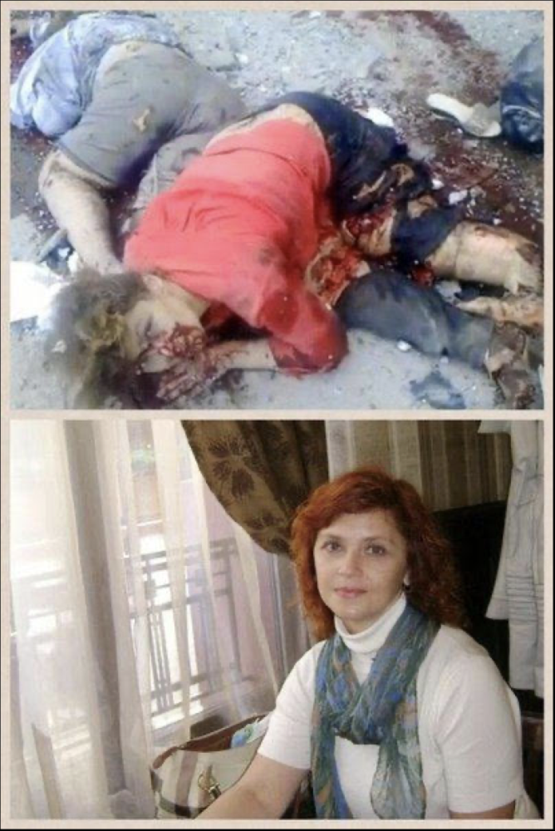

Coming here, I was not only taking up the cause of the Donbass people, who defend Donbass, and defend Russia. Who defends Russia, defends the future of humanity. And humanity includes all good people of all nations. The vast majority of people in the West these days are coprophagous zombies who are too brainwashed to ever redeem themselves. They eat shit, and have learned to like it, and are angry and offended if you suggest they change their diet. But the two percent who are not “woke”, but aware, who know history, can actually perceive reality, who understand what is at stake, and are willing to do more than hit “Like” on a Facebook page to do something about it, these are our audience and the hope for humanity. And there still is hope, because two percent in the U.S. and EU are still tens of millions of people. All good people must stick together and work together. If we do, we can still win and make a better world for everyone. And even if we can’t, let’s give it our best shot. What else better do we have to do?

**Question:** You have made your life in the Donetsk People’s Republic, having obtained citizenship and started a family there. How have local people taken to the “man from Texas” in their midst?

**Russell Bentley:**When I came here in December 2014, I honestly did not expect to live through the winter, and had good reason for that expectation. I was 54 years old, out of shape, didn’t speak Russian, coming to the small side of a big war, the People’s Militia versus the entire might of the NATO-backed Ukrainian army, the third most powerful army in Europe. But I came anyway, and it was the best move I ever made in my life. I had a hard life growing up, and spent five years in U.S. federal prison for marijuana smuggling, but I also did a lot of cool things, a lot of travel, adventure, a lot of fun, and a lot of pleasure. But the last eight years here in Donbass have been the best years of my life. I’ll be 62 years old next month, and how many men in the U.S. or EU, or anywhere, can say that at 62 they are living the best years of their life?

It took a lot of courage to come here to join the DPR army, to fight, to willingly face death, not expecting to win. I’m not bragging, it’s just a simple fact. And by doing so, I learned and proved one of the most important lessons in life: courage is the key to happiness. Because it is impossible to be happy when you are afraid. So do not be afraid. By being brave, I brought myself to the best part of my life. You can do the same.

When I came here, I had no idea or imagination or ambitions about being an “internet star” or a correspondent or anything like that. But I am a poet and singer-songwriter, I have a talent for communication and inspiration and my work with a camera and computer has had more impact than my work with a Kalashnikov or RPG. People know my work and my name and respect me in China, Australia, South Africa, South America, every country in Europe, and, of course, all over the USA, Texas, and Mexico. And Donbass and Russia. But I did not come here looking for fame or fortune. The thing that I am proudest about in my whole life is the respect and friendship of the soldiers I fought with, and the citizens I live with. They know who I am, and really appreciate me being here, and that is my greatest honor.

**Question:**What are your thoughts on how the Western news media has been censoring Russian media and any critical opinion on how the U.S., NATO, and the European Union bear major responsibility for creating conflict with Russia?

**Russell Bentley:**It proves their cowardice and mendacity. Fools hate the wise, cowards hate the brave, and liars hate the truth. The truth is being drowned in an ocean of lies these days, but the truth is still out there, and it is still the truth. It is our most powerful weapon, and that is why they fear it and try to erase it. They know a dollar worth of our truth can overcome a billion dollars worth of their bullshit and lies, so that is why we must defend it at all costs. Courage, truth, solidarity, these are our weapons. We must be ready and willing to die, and to kill who and what needs killing. We are not just fighting for nationality or a race or political philosophy, we are fighting for the future of humanity. Davai!